1. **Write a program to reverse the String (use char[] or String built in method)**

***Program :-***

**package** com.ust.test;

**import** java.util.Scanner;

**public** **class** Sba2Question1

{

**public** **static** **void** main(String[] args)

{

Scanner sc= **new** Scanner(System.***in***);

System.***out***.println("Enter the string : ");

String str= sc.nextLine();

String rev="";

**char** ch;

System.***out***.println("\nThe string is : "+str);

System.***out***.println("\n***STRING REVERSAL***");

**for** (**int** i=0; i<str.length(); i++)

{

ch= str.charAt(i); //extracts each character

rev= ch+rev; //adds each character in front of the existing string

}

System.***out***.println("\nThe reversed string is "+rev);

sc.close();

}

}

***Output:-***

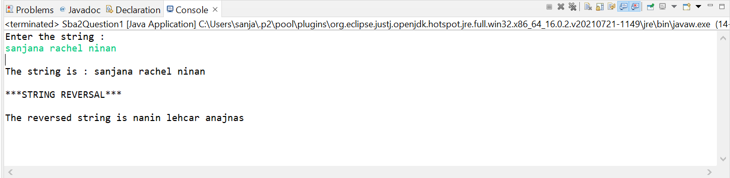

1. **Write programs to depict the usage of contains(), length(), replace(), concat(), equals()**

***Program :-***

**package** com.ust.test;

**public** **class** Sba2Question2

{

**public** **static** **void** main(String[] args)

{

System.***out***.println("The program shows the usage of contains(), length(), replace(), concat(), equals()");

String str1 = "My name is Sanjana Rachel Ninan";

String str2 = "Summer";

String str3 = "Winter";

//contains()

System.***out***.println("\n***Usage of contains()***");

System.***out***.println("Is *name is Sanjana* present in the string ? "+str1.contains("name is Sanjana"));//Checks if "name is Sanjana" is present in the string

System.***out***.println("Is *Ninan#.* present in the string ? "+str1.contains("Ninan#."));//Checks if "Ninan#." is present in the string

//length()

System.***out***.println("\n***Usage of length()***");

System.***out***.println("Length of the string is : "+str1.length());//Gives the length of the string

//replace()

System.***out***.println("\n***Usage of replace()***");

String replaceString=str2.replace('m','x');

System.***out***.println("The replaced string (str2 = Summer) is : "+replaceString);//Replaces all m with x

String replaceString2=str3.replace("ter","ddd");

System.***out***.println("The replaced string (str3 = Winter) is : "+replaceString2);//Replaces ter with ddd

//concat()

System.***out***.println("\n***Usage of concat()***");

String concatString=str2.concat(str3);

System.***out***.println("The concatenated string is : "+concatString);//Concatenates str2 and str3

//equals()

System.***out***.println("\n***Usage of equals()***");

System.***out***.println("The strings str2 and str3 are equal ? : "+str2.equals(str3));

}}

**Output:-**

